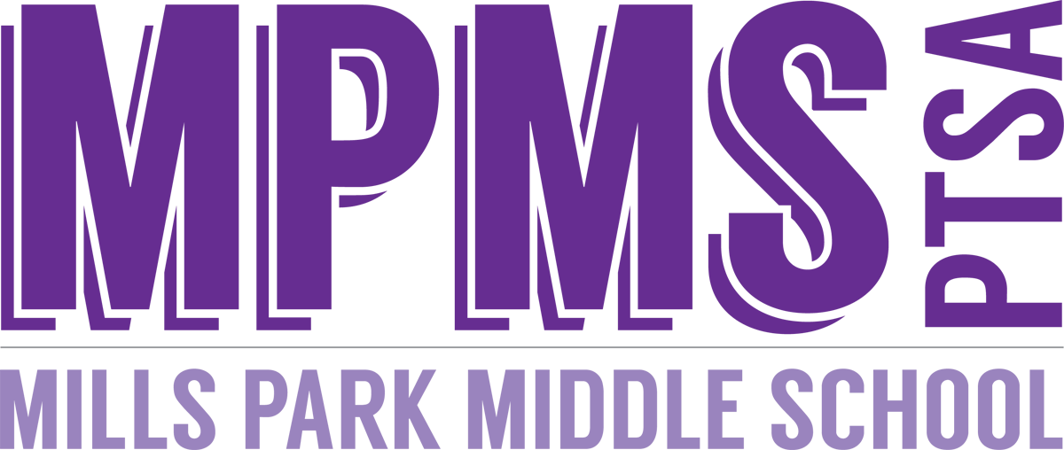

The PTSA’s mission is to make every child’s potential a reality by engaging and empowering families and communities to advocate for all children.

PTSA Instructional Grant Application Guidelines
(updated 3/2022)

Description: To support our teachers, staff, and students, the PTSA is pleased to provide grants for instructional tools and services that align with PTSA’s mission and have the greatest and most significant effect for MPMS students. Most favorable grant applications include requests for instructional tools and services that:
- Enhance the curriculum by providing additional relevant educational experiences and/or further improve the quality of the learning environment for students,
- Are of a durable nature for continued use over multiple school years (such as technology equipment and books), but non-durable items will also be considered (such as education website subscriptions and consumable supplies),
- Affect as many of the applicant’s students as possible,
- Are not easily donated by classroom parents (such as general office supplies), and
- Could not or would not be provided by MPMS or WCPSS.
All instructional tools and services purchased/reimbursed by MPMS PTSA should be considered the property of MPMS or MPMS PTSA and should remain as such should the grant applicant(s) leave MPMS. Grants are only awarded for costs incurred during the current budget year (July 1-June 30).

Eligibility: MPMS Teachers and Staff who are members of the MPMS PTSA

Award: Any amount but will be limited by the total amount budgeted for Instructional Grants for the current school year.

Award Process Timeline: Applications may be filled out at any time and will be reviewed monthly. Please return the completed form to the Lead Secretary for the Principal’s approval. Upon approval by the Principal, the grant application will be forwarded to the Grants Committee for review and approval. The Grants Committee will then present the application to the PTSA executive board for final approval and the release of awarded funds to the primary contact listed on the application.

Award Criteria: New grant applications are reviewed monthly, beginning in September, and are ranked using the criteria explained in the Description section. Grants are then awarded from highest to lowest ranking until Instructional Grant funds for the current school year are exhausted.

Required Documents: Because PTSA funds are for reimbursement only, please include appropriate original legible receipt(s) with the completed Grant Application form. If the application is not accompanied by receipt(s), grant recipients will have six weeks from notification of the award to submit receipts before the award is relinquished.

Contact: For questions, please contact: grants@mpmsptsa.org.

Thank you for all that you do for the student of MPMS!

The PTSA’s mission is to make every child’s potential a reality by engaging and empowering families and communities to advocate for all children.

PTSA INSTRUCTIONAL GRANT APPLICATION

APPLICANT’S NAME: __________________________________________ DATE: ____________________
EMAIL: ______________________________________________ PHONE NUMBER: _____________________

PURPOSE OF GRANT (please include information about the instructional tools and/or services sought and a brief statement about how they will be used to enhance your curriculum):

______________________________________________________________________________________________________________________________________________________________________________________________________________________________________________________________________________________________________________________________________________________________________________________________________________________________________________________________________________________________________________________________________________________________________________________________________________________________________________________

GRADE(S) IMPACTED: _______________________________ NUMBER OF STUDENTS: _________________________

THIS GRANT REQUEST IS INTENDED TO BE USED FOR (check one):
SINGLE EVENT_____ CURRENT SCHOOL YEAR_____ MULTIPLE SCHOOL YEARS_____

DATE FUNDS NEEDED: ___________________ AMOUNT REQUESTED: _______________________

***FOR BOARD USE ONLY***

Principal Signature for approval: _____________________________________________________________
Date Grant Application Received by PTSA: ________________
PTSA Grant Committee Recommendation: Approve/ Table/ Deny Date:_______________
PTSA President’s Signature: _________________________________________________
Date of Reimbursement Check: ______________________________
Check Number: ___________________

